**Hands on with JMeter GUI**

As soon as you launch JMeter , you will see 2 elements

1. Test Plan
2. Workbench

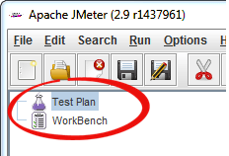

**Test Plan**

Test Plan is where you add elements required for your JMeter Test.

It stores all the elements (like ThreadGroup, Timers etc) and their corresponding settings required to run your desired Tests.

Following figure shows an example of Test Plan

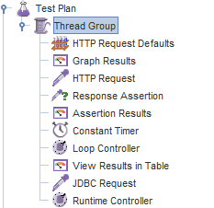

**WorkBench**

The WorkBench simply provides a place to store test elements **temporarily**. WorkBench has no relation with Test Plan. JMeter will **not save** the contents of the WorkBench. It only saves the contents of the Test Plan branch

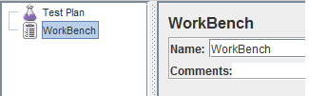

 "WorkBench" will be used in our tutorial HTTP Proxy Server Recording Test

For now , ignore it.

**Adding Elements**

Adding Elements is the **essential** step to build a Test Plan because without adding elements, JMeter **cannot** execute your Test Plan

A Test Plan includes many Elements such as Listener, Controller, and Timer

You can add an element to test plan by right-clicking on a **Test Plan**, and choose new elements from "**Add**" list.

Suppose, you want to add 2 elements to Test Plan **BeanShell Assertion** and **Java Request Default**

* Right click **Test Plan *->* Add *->*Assertion*->* Bean Shell Assertion**
* Right click **Test Plan *->* Add *->*Config Element *->* Java Request Default**



You can also **remove** unused element

Let's say, you want to remove element "**HTTP Request Defaults**", select "HTTP Request Default" -> Right click-> choose **Remove** from the context menu -> Click **Yes**to confirm delete this element on message box

**Loading and Saving Elements**

**Saving Elements**

Suppose you have already added an element name "BeanShell **Assertion**".  Now you want to save it.

Right click BeanShell Assertion -> select **Save Selection As**

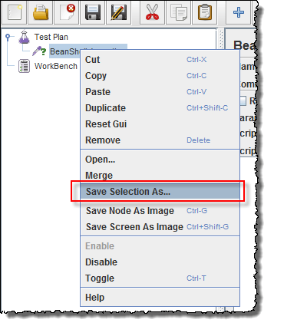

A dialog box display, click S**ave** button to save your elements under default name **BeanShell Assertion.jmx**. You can choose other name if you want

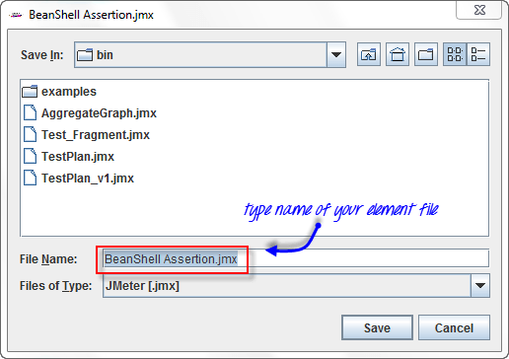

JMeter Test Elements and Test plan are stored in **\*.JMX** format. **JMX** is standing for **Java Management Extensions.**

**Loading Elements**

Loading exist element helps you save your time required to create & configure new elements

Let's say,  that you have an existing element in Test Plan: ***Java Request Default***

Right click **Java Request Defaults**-> select **Merge**



Choose the **Elements** (**BeanShell Assertion.jmx.**) file in the directory. This element will be added to your current test plan.

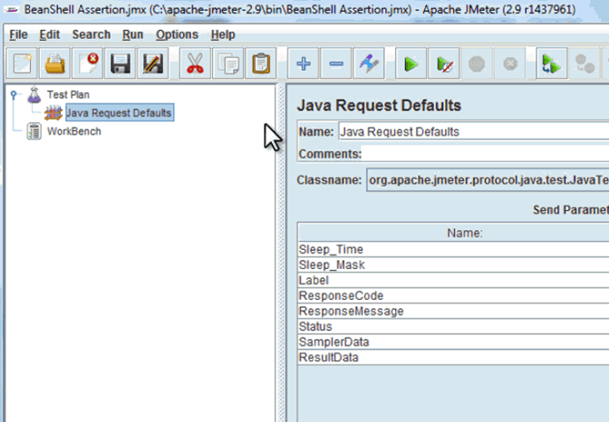

**Configuring Elements**

In order to configure any Element

1. Select the element in the Tree on Left Pane
2. Enter configuration settings on the Right Pane

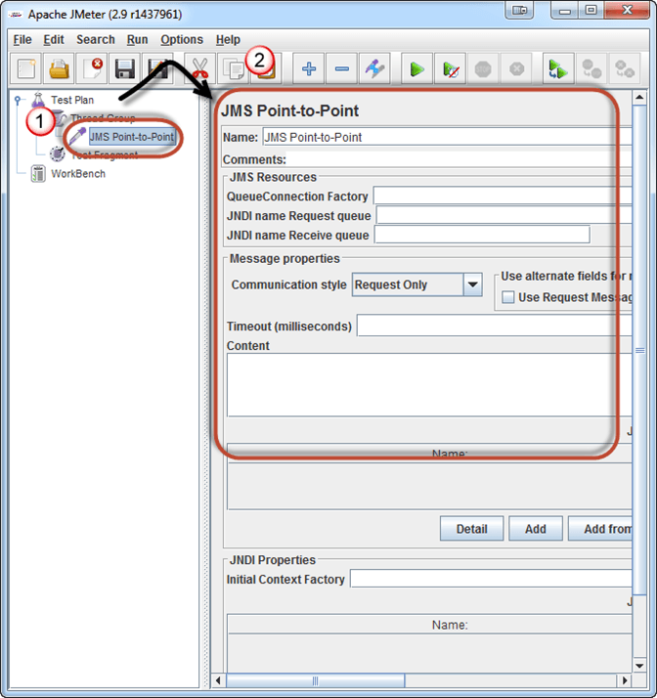

**Running and Stopping a Test Plan**

Before running a test, you should save your Test Plan first. Saving your Test Plan helps you avoid unexpected error when running the test plan. Steps to save Test plan -

1. ***File -> Save Test Plan as-> a Dialog box display***
2. *Enter a filename of Test Plan* ***->****click****Save***



Note: Saving a Test Plan is **different** from saving elements.

|  |  |
| --- | --- |
| **Saving a Test Plan** | **Saving an Element** |
| Test Plan consists of one or many elements | Element is a basic component of JMeter |
| When you save your Test Plan, all those elements in the plan are saved | When you save your elements, only one element is saved. |

**Create Combo Test Plan**

You can **merge** one or many Test Plans to create a **combo** Test Plan as shown in below figure

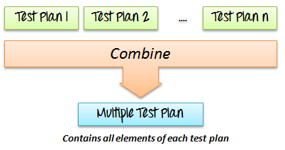

Suppose you already have an existing Test Plan name ***Test_Fragment.jmx*** on your computer (This article includes this file).You can merge this test plan to current Test Plan on JMeter to create a new Test Plan.



Now all the test elements in file ***Test_Fragment.jmx*** are added to your current test plan as shown in the figure below

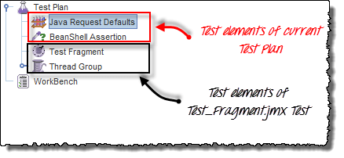

**Run Test Plan**

To run your single or multiple test plans, choose **Start** (Control + R) from the **Run** menu item.

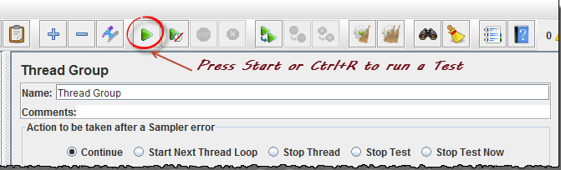

When JMeter is running, it shows a small green box at the right hand end of the menu bar.